JOINS

Join:- A JOIN combines rows from two or more tables using a common column.
No | Join Type | Description
1 | INNER JOIN | Only rows with a match in both tables.
2 | LEFT JOIN | All from Left + Matches from Right.
3 | RIGHT JOIN | All from Right + Matches from Left.
4 | FULL JOIN | All records from both tables
5 | CROSS JOIN | Every combination of rows.

INNER JOIN:- Returns only matching records from both the tables
SELECT
e.emp_id,
e.emp_name,
e.salary,
d.dept_name,
d.location
FROM employees e
INNER JOIN departments d
ON e.dept_id = d.dept_id;
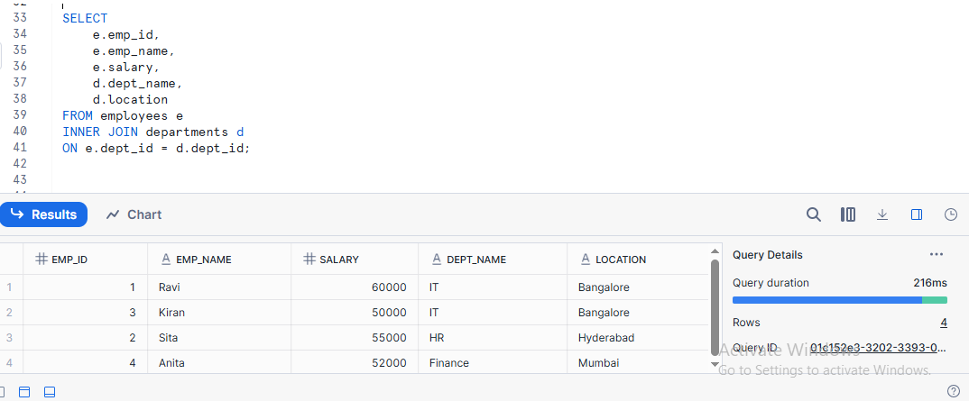

LEFT JOIN:- Returns all records from the left table and matching records from the right table
SELECT
e.emp_id,
e.emp_name,
e.salary,
d.dept_name,
d.location
FROM employees e
LEFT JOIN departments d
ON e.dept_id = d.dept_id;

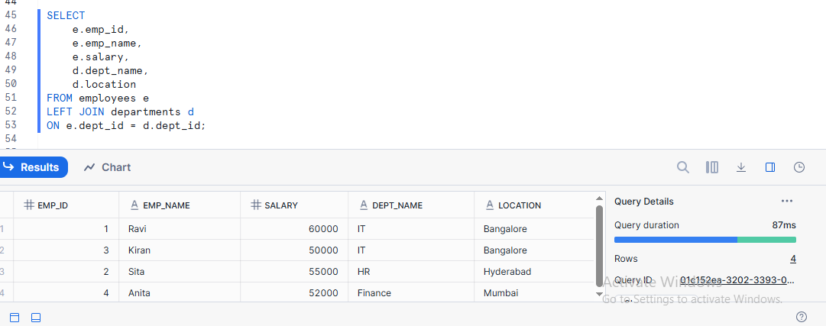

RIGHT JOIN:- Returns all records from the Right table and matching records from the left table
SELECT
e.emp_id,
e.emp_name,
e.salary,
d.dept_name,
FROM employees e
RIGHT JOIN departments d
ON e.dept_id = d.dept_id;
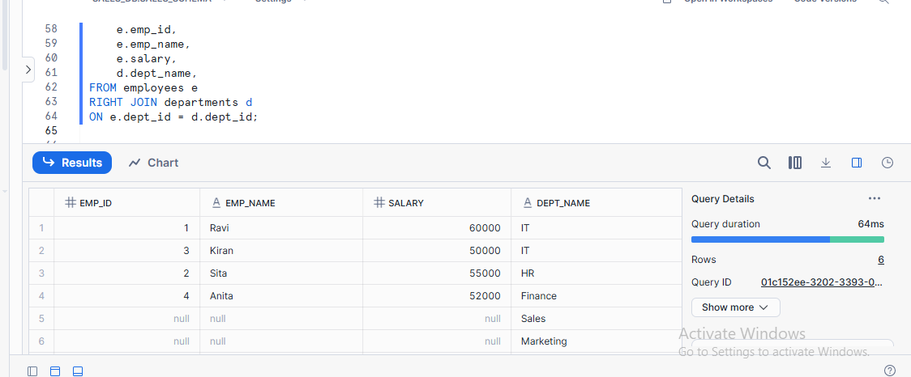
Full Outer Join:-
A FULL OUTER JOIN returns all rows from both tables.
SELECT
e.emp_id,
e.emp_name,
e.dept_id,
d.dept_name
FROM employees e
FULL OUTER JOIN departments d
ON e.dept_id = d.dept_id;

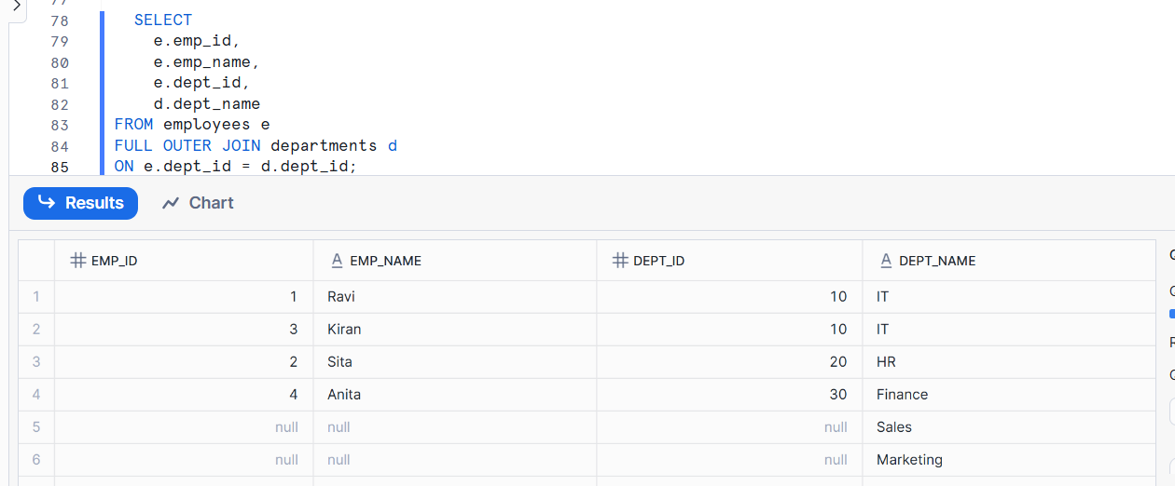
CROSS JOIN :- Combines all rows from two tables, creating all possible pairs
SELECT
e.emp_name,
d.dept_name,
d.location
FROM employees e
CROSS JOIN departments d;

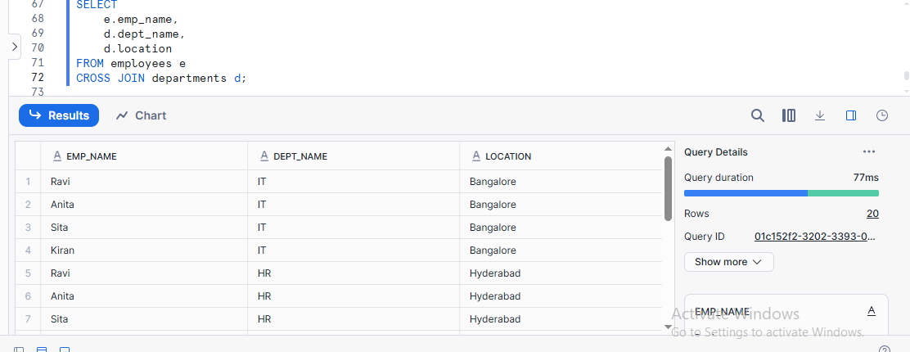

UNION Operators in SQL
There are 2 types of UNION operators in SQL.
1.UNION
2.UNION ALL

Union
UNION combines results from two SELECT queries and removes duplicate rows
Union All
UNION ALL combines results from two SELECT queries and keeps duplicate rows.
UNION
Create Table
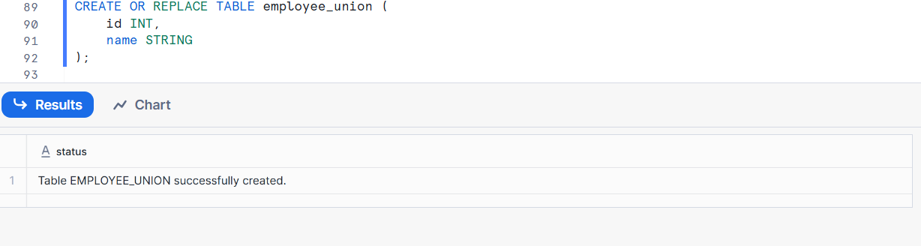
Insert Data
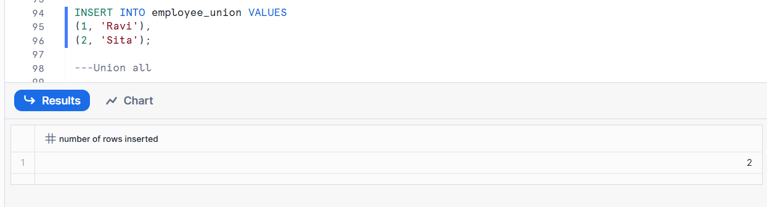
Union All
Create Table

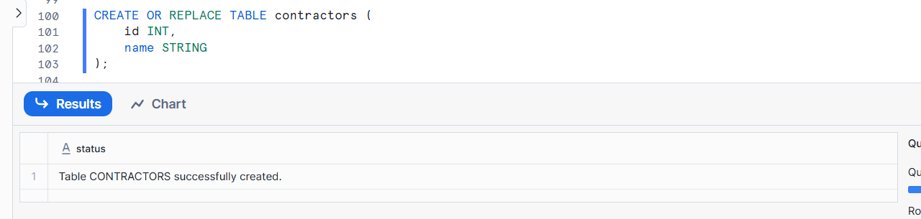
Insert Data
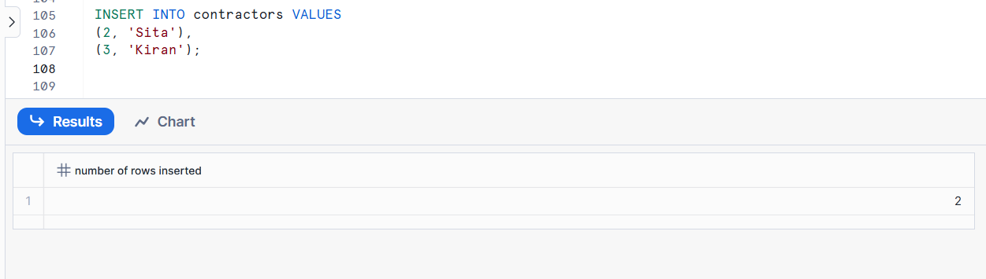
UNION Example (removes duplicates)
SELECT id, name FROM employee_union
UNION
SELECT id, name FROM contractors;

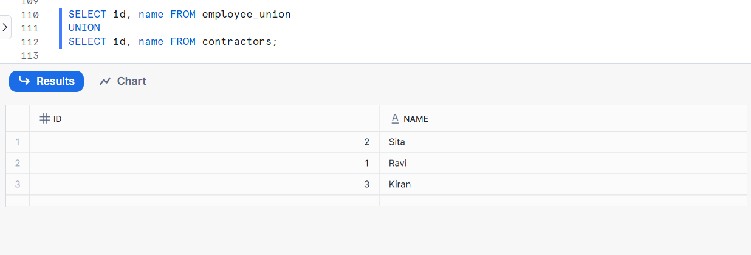
UNION ALL Example (keeps duplicates)
SELECT id, name FROM employee_union
UNION ALL
SELECT id, name FROM contractors;
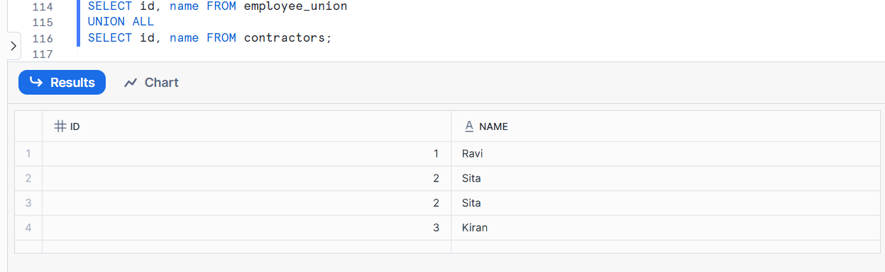

Using lateral joins
A Lateral Join allows a subquery on the right side of a JOIN to use columns from the left table.
CREATE OR REPLACE TABLE employees_lateral (
emp_id INT,
emp_name STRING,
skills ARRAY
);
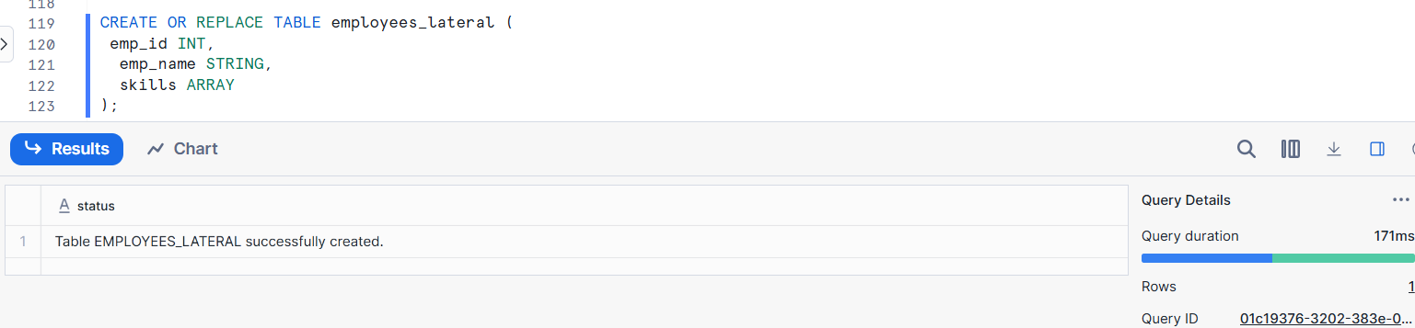
Insert data
INSERT INTO employees_lateral
SELECT
1,
'Ravi',
ARRAY_CONSTRUCT ('SQL', 'Snowflake');
INSERT INTO employees_lateral
SELECT
2,
'Sita',
ARRAY_CONSTRUCT('Python', 'AWS');
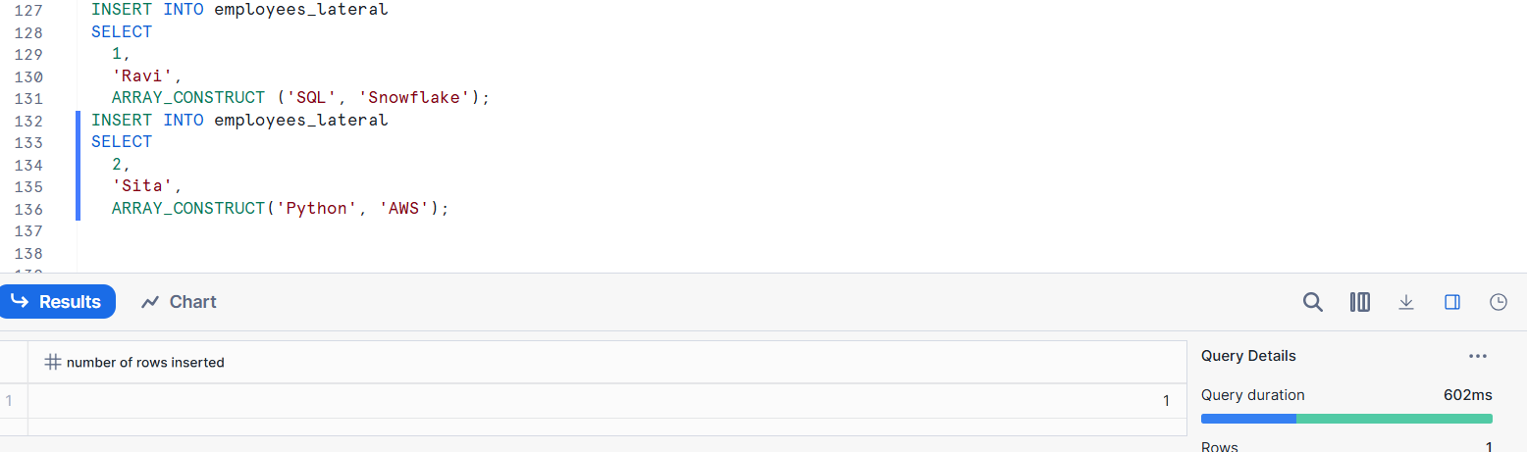
ARRY_CONSTRUCT means store multiple values in a single column
Verify data
select * from employees_lateral;
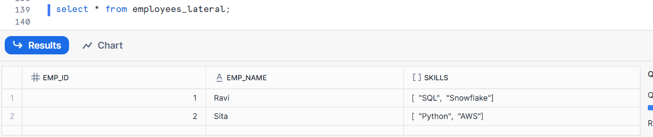

Using Lateral with flatten
SELECT emp.emp_id, emp.emp_name, index, value AS skill_name
FROM employees_lateral AS emp,
LATERAL FLATTEN(INPUT => emp.skills) AS Skills
ORDER BY emp_ID;
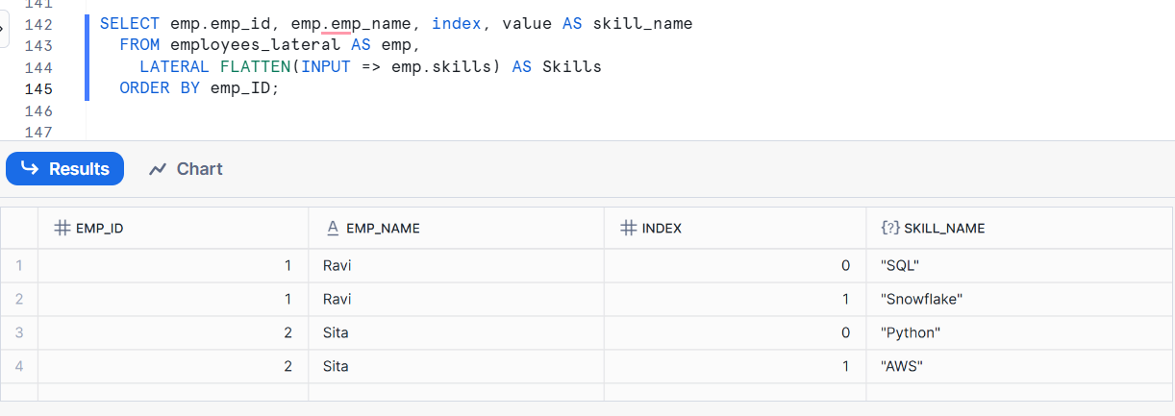
LATERAL FLATTEN :-LATERAL FLATTEN converts array or JSON data into multiple rows.

Subqueries
A subquery is a query inside another query.
In this example we want to find the employees whose salary is more than the average salares of all the employees
SELECT EMP_NAME
FROM employees
WHERE salary > (SELECT AVG(salary) FROM employees);
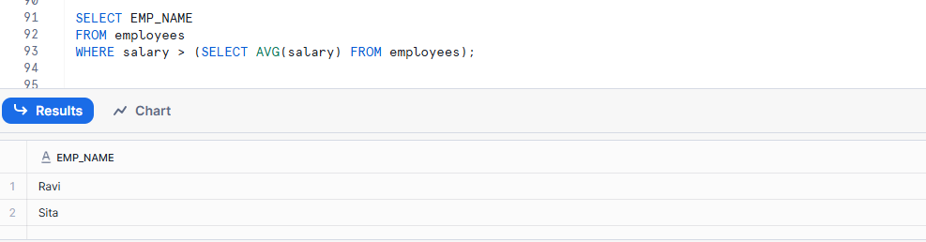
Querying Hierarchical Data
Hierarchical data has a parent–child relationship.
A parent–child relationship means one record (parent) is linked to one or more records (children).
Each child belongs to one parent, but a parent can have many children
Create Table
CREATE OR REPLACE TABLE employees (
emp_id INT,
emp_name STRING,
manager_id INT
);

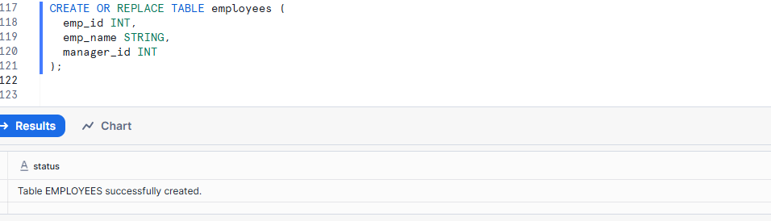
Insert Data
INSERT INTO employees VALUES
(1, 'Ravi', NULL), -- CEO
(2, 'Sita', 1), -- Reports to Ravi
(3, 'Kiran', 1),
(4, 'Anita', 2) ; -- Reports to Sita
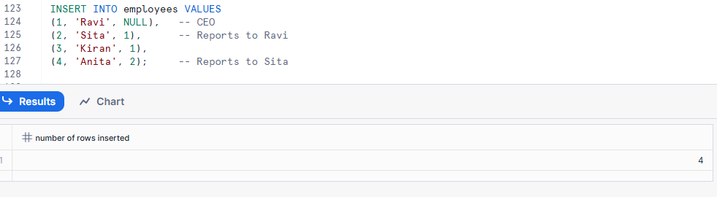
Solution: Recursive CTE
WITH RECURSIVE emp_hierarchy AS (
-- Level 1: Top manager
SELECT
emp_id,
emp_name,
manager_id,
1 AS level
FROM employees
WHERE manager_id IS NULL
UNION ALL
-- Level 2+: Subordinates
SELECT
e.emp_id,
e.emp_name,
e.manager_id,
h.level + 1
FROM employees e
JOIN emp_hierarchy h
ON e.manager_id = h.emp_id
)
SELECT * FROM emp_hierarchy;
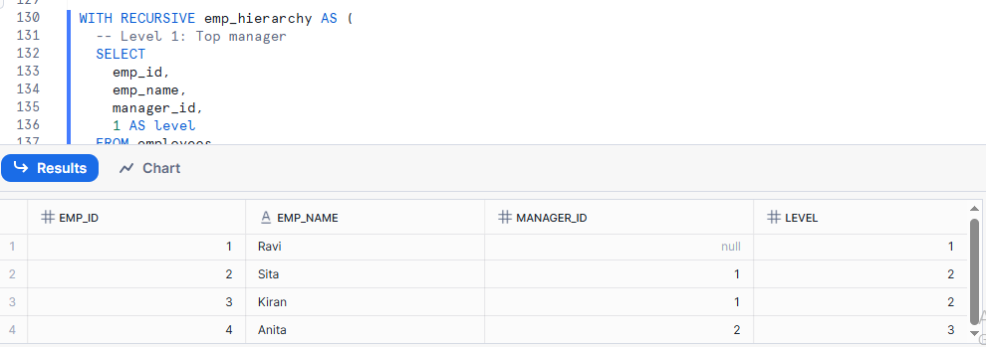

Common Table Expressions (CTE)
A Common Table Expression (CTE) is a temporary named result set that helps break complex SQL queries into simpler, readable parts.
CREATE OR REPLACE TABLE SALES (
ID INT,
AMOUNT NUMBER
);
INSERT INTO SALES VALUES
(1, 500),
(2, 1500),
(3, 3000);

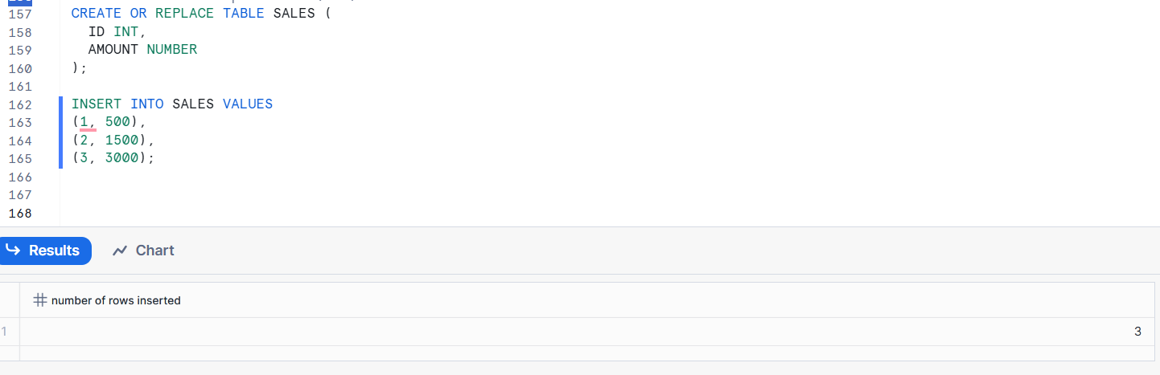
Use a CTE
CTE = temporary table for one query
with average as (SELECT AVG(salary) avg_sal FROM employees)
SELECT *
FROM employees
WHERE salary > (SELECT avg_sal FROM average);

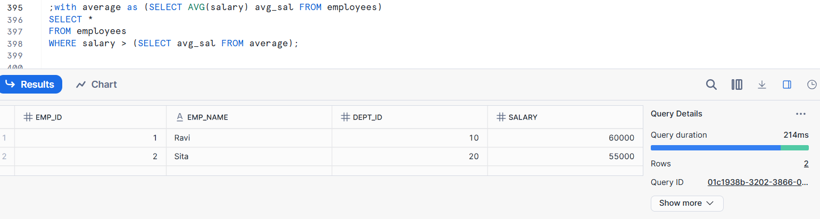

Using full-text search
Full-text search allows you to search text data (words or phrases) inside columns efficiently.
Create a table
CREATE OR REPLACE TABLE ARTICLES (
ID INT,
CONTENT STRING
);
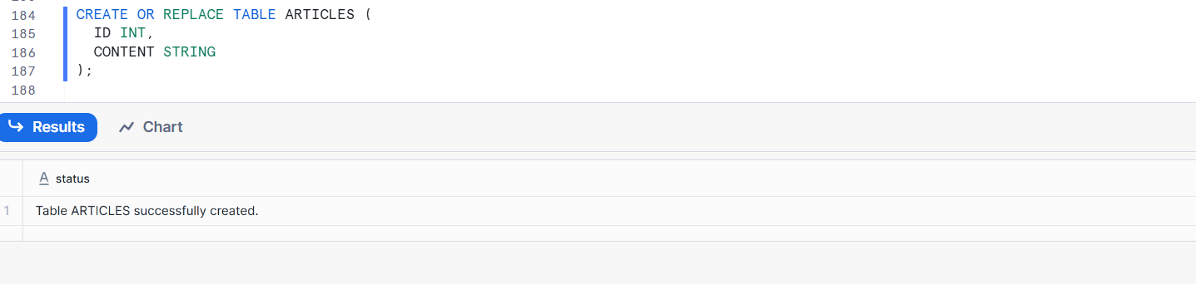
Insert Data
INSERT INTO ARTICLES VALUES
(1, 'Snowflake is a cloud data platform'),
(2, 'Snowflake supports SQL queries'),
(3, 'Data warehousing with Snowflake');

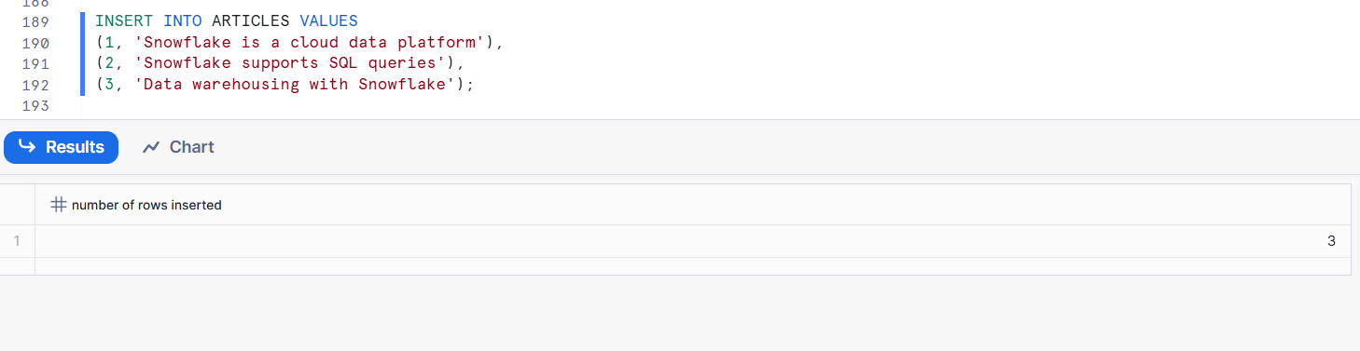
Full-text search using LIKE
SELECT *
FROM ARTICLES
WHERE CONTENT LIKE '%Snowflake%';

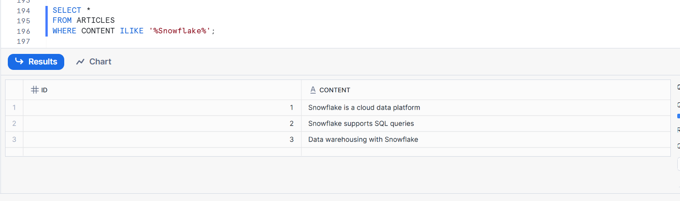

Analyzing time-series data
Analyzing time-series data :- checking how data changes day by day or over time.

CREATE OR REPLACE TABLE "SALES" (

sale_date DATE,

amount NUMBER);
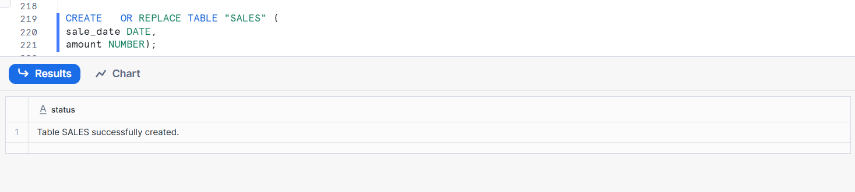
Insert Data
INSERT INTO SALES VALUES ('2025-12-27', 100),
('2025-12-28', 200),
('2025-12-29', 300),
('2025-12-30', 400);
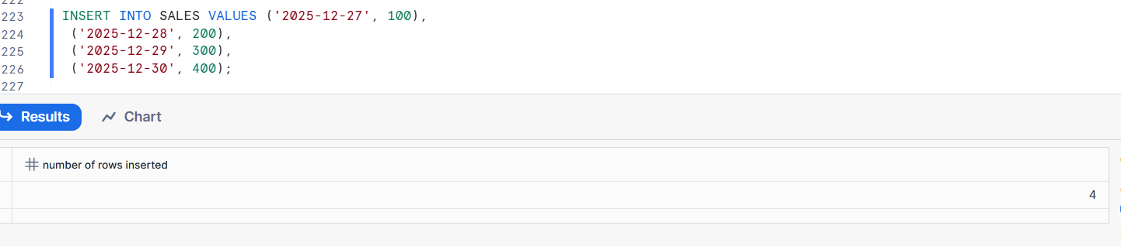
View the data
SELECT * FROM sales ORDER BY sale_date;
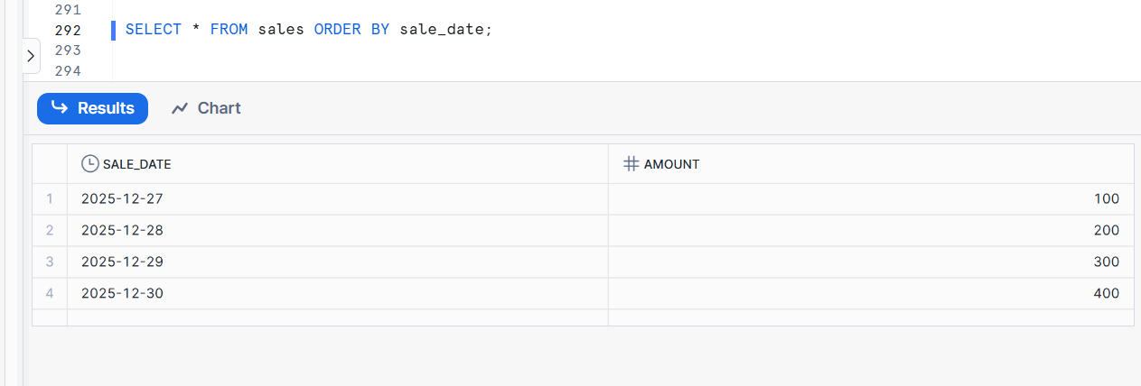
Day-by-day change
SELECT
sale_date,
amount,
amount - LAG(amount) OVER (ORDER BY sale_date) AS daily_change
FROM sales;
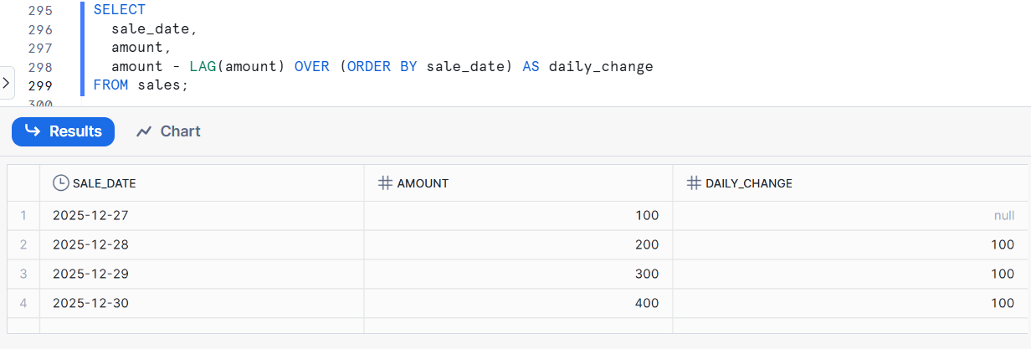
Running total
SELECT
sale_date,
amount,
SUM(amount) OVER (ORDER BY sale_date) AS running_total
FROM sales;

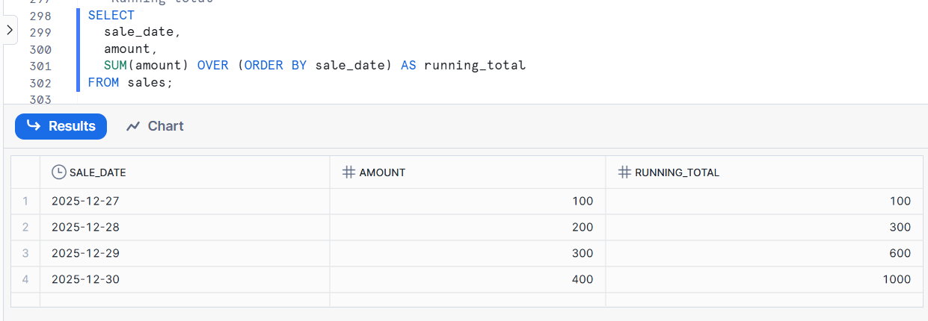
Moving average
SELECT
sale_date,
amount,
AVG(amount) OVER (
ORDER BY sale_date
ROWS BETWEEN 2 PRECEDING AND CURRENT ROW
) AS moving_avg_3_days
FROM sales;
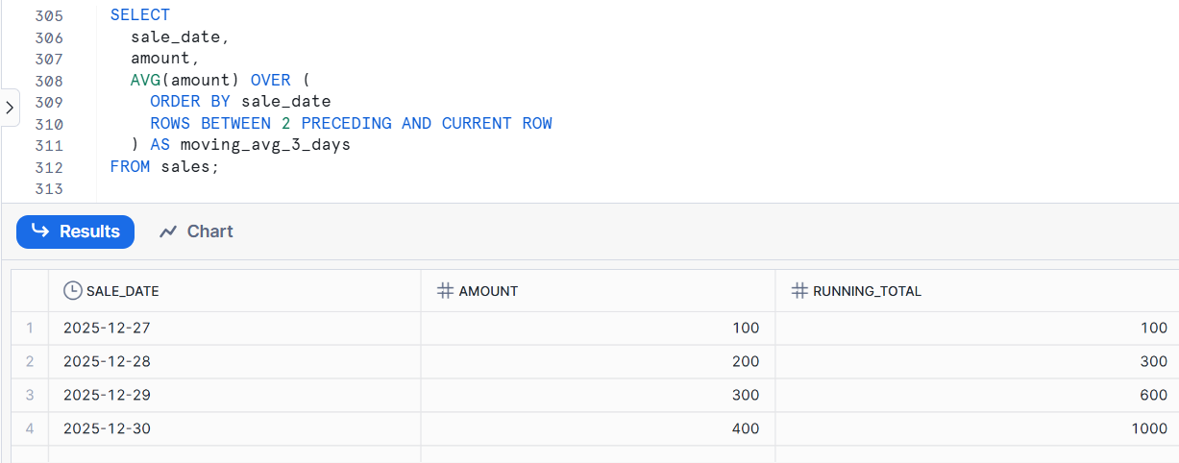

Monthly aggregation

SELECT
DATE_TRUNC('MONTH', sale_date) AS month,
SUM(amount) AS total_sales
FROM sales
GROUP BY month
ORDER BY month;
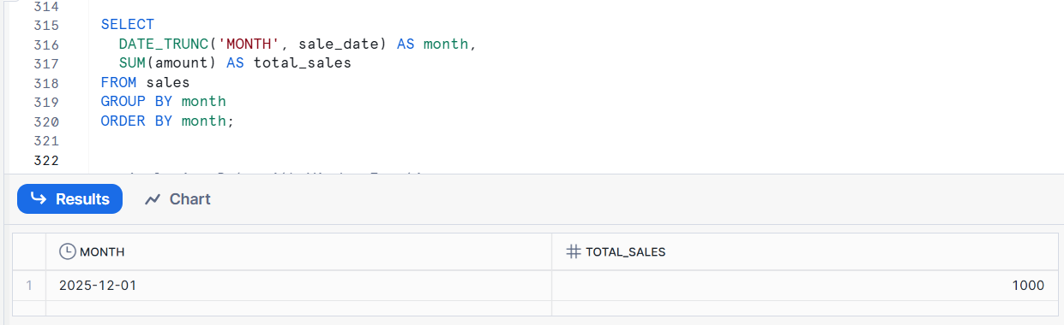
DATE_TRUNC = cut the date to a specific level

Analyzing data with window functions
Window functions perform calculations across related rows without grouping them into one row.
Create Table
CREATE OR REPLACE TABLE SALES (
SALE_DATE DATE,
AMOUNT NUMBER
);
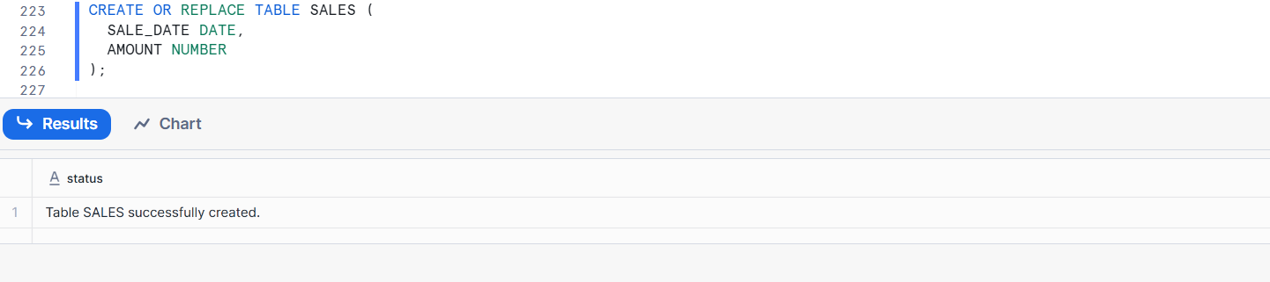
Insert Data
INSERT INTO SALES VALUES
('2024-01-01', 100),
('2024-01-02', 200),
('2024-01-03', 150);
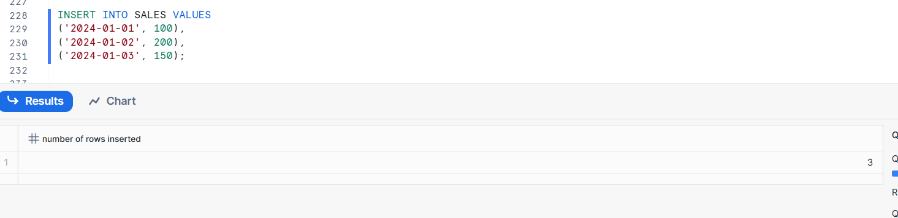
Running total using window function
SELECT
SALE_DATE,
AMOUNT,
SUM(AMOUNT) OVER (ORDER BY SALE_DATE) AS RUNNING_TOTAL
FROM SALES;
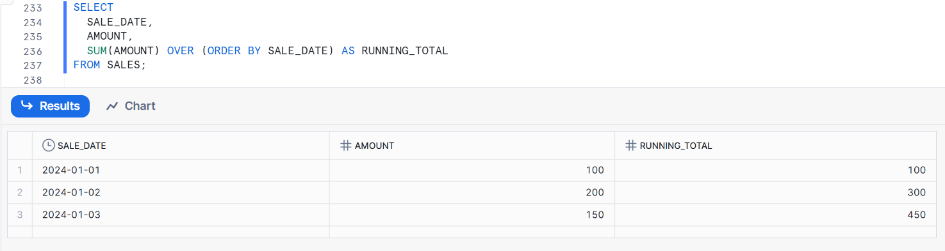

Match Recognize
MATCH_RECOGNIZE is used to find patterns or sequences of rows in data.

SELECT
SALE_DATE,
AMOUNT,
LAG(AMOUNT) OVER (ORDER BY SALE_DATE) AS PREV_AMOUNT
FROM SALES
QUALIFY AMOUNT > LAG(AMOUNT) OVER (ORDER BY SALE_DATE);

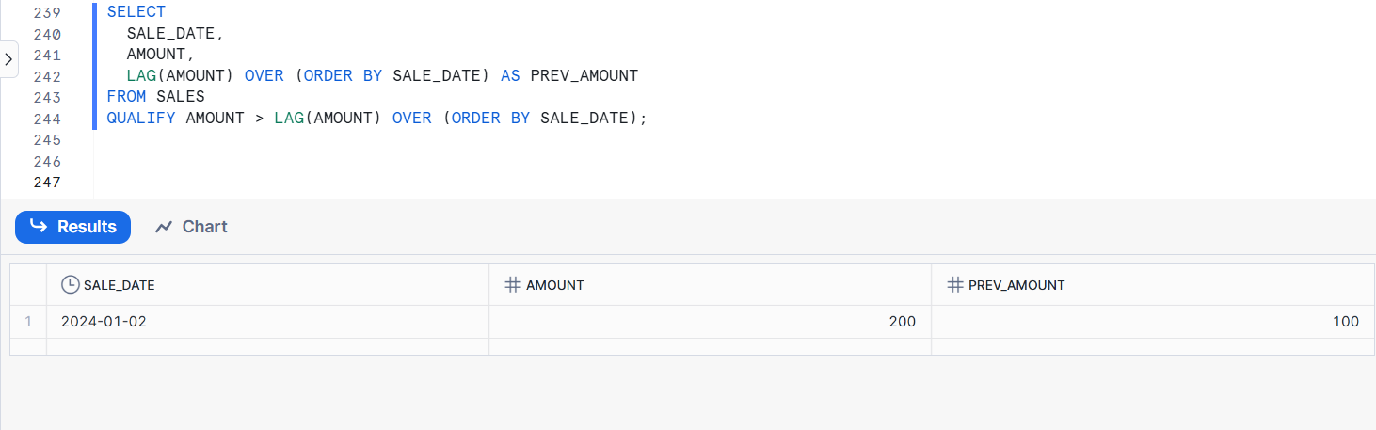
LAG(AMOUNT) gets the previous row’s amount
PREV----Previces amount
QUALIFY filters rows like where clause

Sequences
A sequence is an object that automatically generates unique numbers.
Create a sequence
CREATE SEQUENCE order_seq START = 1 INCREMENT = 1;

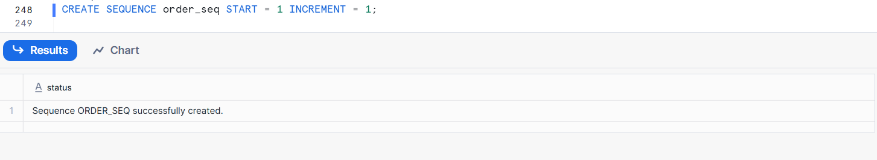
Insert with explicit date value
INSERT INTO SALES (SALE_DATE, AMOUNT)
VALUES ('2024-01-10', 500);
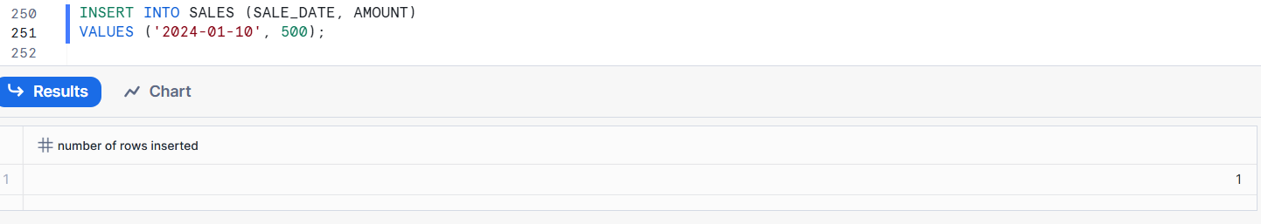

Persisted Query Results
Persisted Query Results means Snowflake remembers the answer of a query and gives the same answer again without running it again.
When a query is executed, the result is persisted (i.e. cached) for a period of time. At the end of the time period, the result is purged from the system.
For persisted query results of all sizes, the cache expires after 24 hours.

Run once → result will be save in cache→ when we execute the same query again it will reuse the results from the cache (fast & no extra cost)
Example:-
SELECT COUNT(*) FROM SALES;
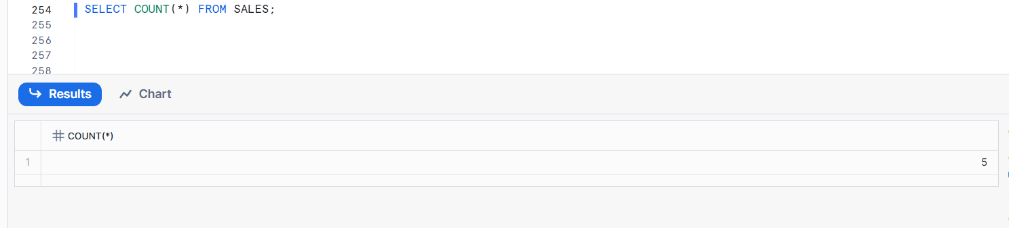

Distinct Counts
Distinct Count means counting unique values only (duplicates ignored).
Create Table
CREATE OR REPLACE TABLE CUSTOMER_ORDERS (
ORDER_ID INT,
CUSTOMER_ID STRING
);
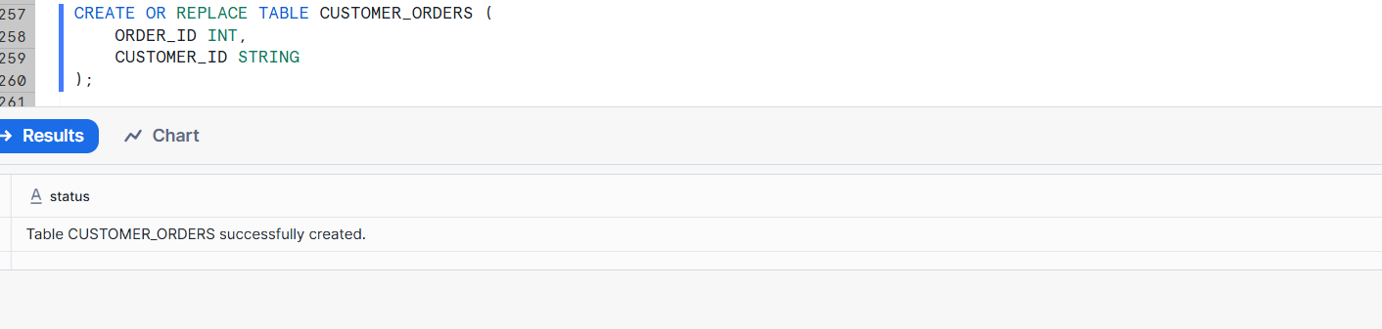
Insert Data
INSERT INTO CUSTOMER_ORDERS VALUES
(101, 'C1'),
(102, 'C1'),
(103, 'C2'),
(104, 'C3'),
(105, 'C3');
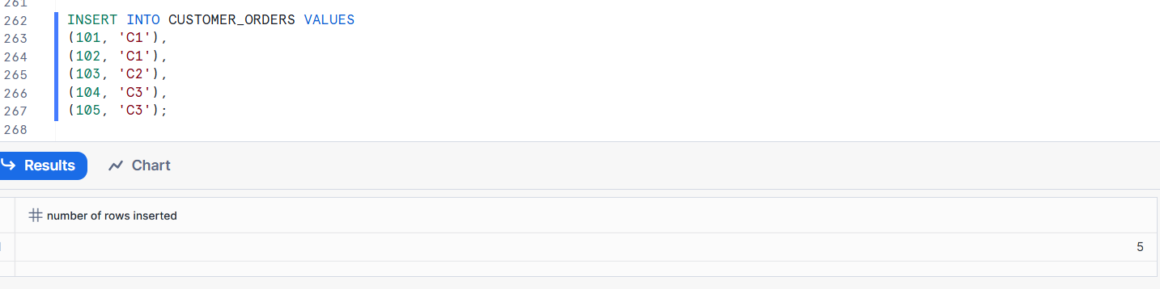
select * from CUSTOMER_ORDERS;
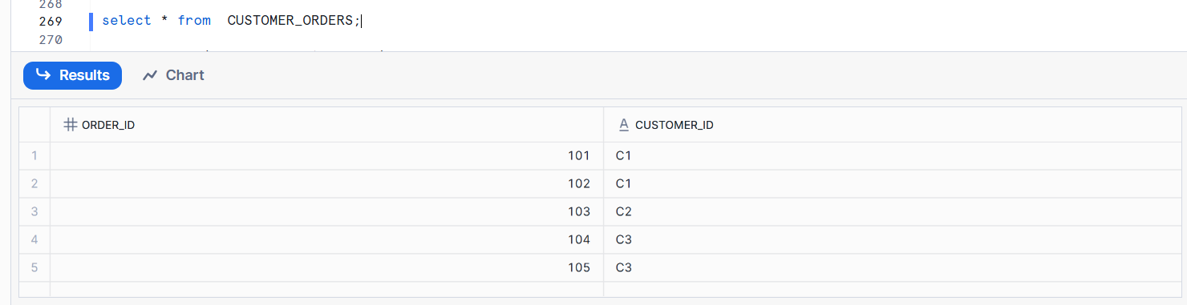
Unique Values:-
SELECT DISTINCT CUSTOMER_ID AS UNIQUE_CUSTOMERS
FROM CUSTOMER_ORDERS;
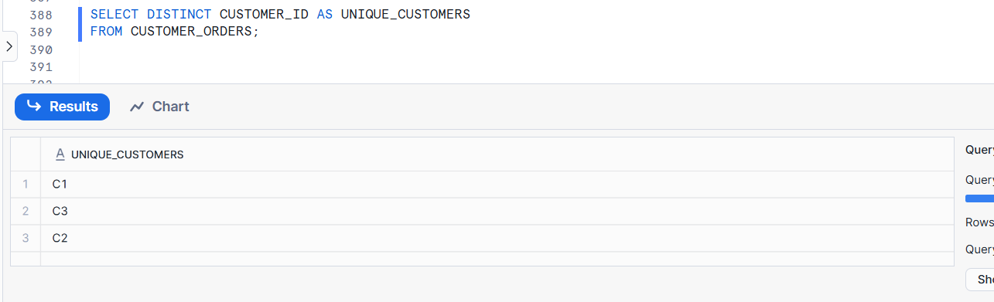

Estimating Percentile Values
Estimation gives a fast approximate result instead of exact, used for very large data.
Example:-
SELECT APPROX_COUNT_DISTINCT (customer_id)
FROM ORDERS;
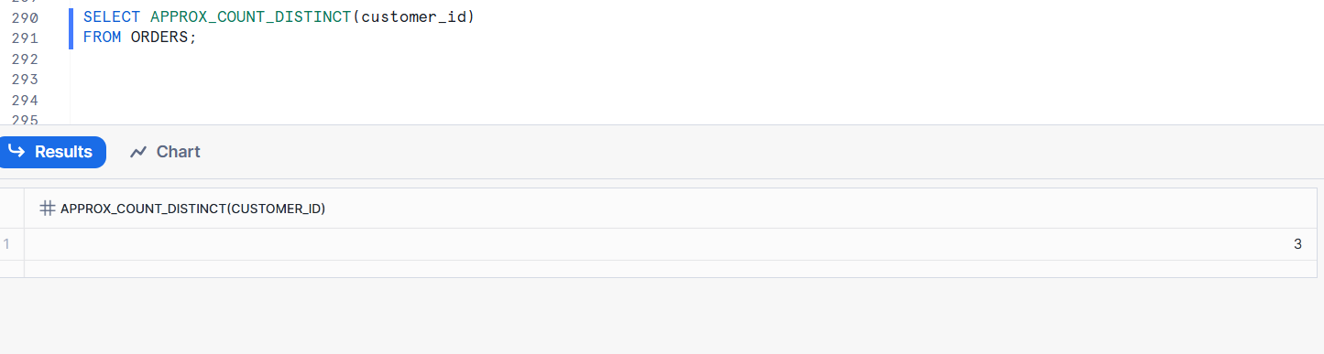

Arrays for Hierarchical Aggregations
Arrays for hierarchical aggregations mean storing all child values of a hierarchy level in an array and then using that array to quickly calculate totals for parent levels (like Category → Subcategory → Product).
Hierarchy = Parent → Child
Array = List of child values
Parent total = sum of array values
Sales Table
Category Subcategory Amount
Electronics Mobile 100
Electronics Mobile 200
Electronics Laptop 300
Furniture Chair 150
Electronics category array:
[100, 200, 300]
Furniture category array:
[150]
Aggregation Using Arrays
Electronics total = 100 + 200 + 300 = 600
Furniture total = 150
Hierarchy View
Category
└── Subcategory
└── Sales Amounts (stored in array)
Why Arrays Are Useful
Faster aggregation
Efficient roll-up calculations

Monitor query activity with Query History
What is Query History?
Query History shows all queries executed in Snowflake, along with details like:
Who ran the query
When it ran
How long it took
Whether it succeeded or failed
How much compute it used
Why Monitor Query Activity?
Find slow queries
Track failed queries
Monitor warehouse usage
Control cost
Audit who ran what query

Using query insights to improve performance
Query Insights help you analyze slow or expensive queries and show why they are performing poorly.
Why Use Query Insights?
Identify slow-running queries
Detect inefficient joins
Find missing pruning / filtering
Reduce warehouse cost
Improve overall performance

Query Hash
Query Hash identifies logically identical queries and helps Snowflake reuse results and optimize performance.
Why Query Hash is Important
Detect duplicate queries
Enable result cache reuse
Analyze repeated workloads
Reduce compute cost
Improve performance

Top-K pruning
Top-K pruning is a query optimization technique where Snowflake stops scanning unnecessary data once it finds the top K rows required by a query.
Simple Example
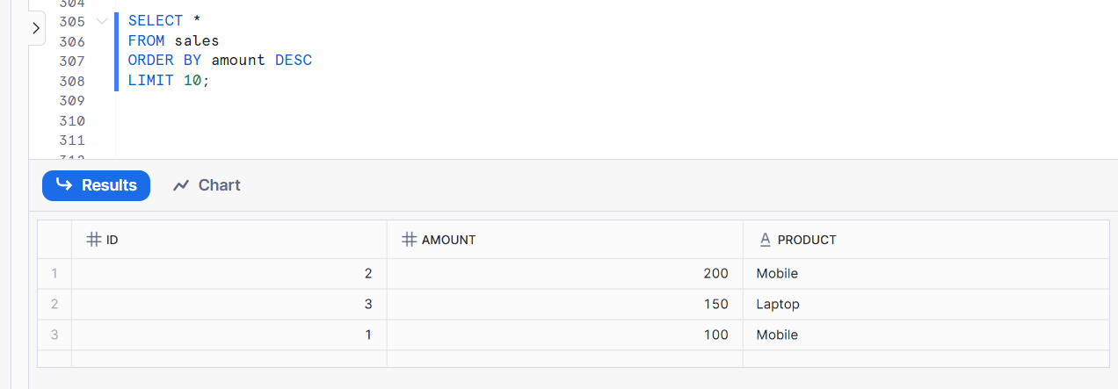

How Top-K Pruning Works:-
Query has ORDER BY + LIMIT
Snowflake starts scanning micro-partitions
Once top-K results are identified
Remaining partitions are pruned (skipped)

Cancel Statements
A Cancel Statement is used to stop a running SQL query before it finishes execution in Snowflake.
Cancel a Query:-
SELECT SYSTEM$CANCEL_QUERY('<query_id>');

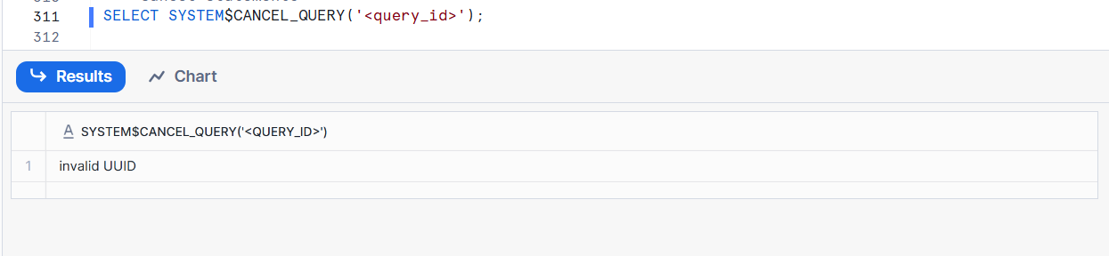
Why Do We Cancel Queries:-
Query is running too long
Query is using too much compute
Query was run by mistake
To control cost
To free up warehouse resources

